Projects Flow

Dental Practise Management Software(Denta)

Phase 1 — Clinic Setup (Do this once, before any patient walks in)
1. Dentist → Add all dentists with specialization, contact, salary

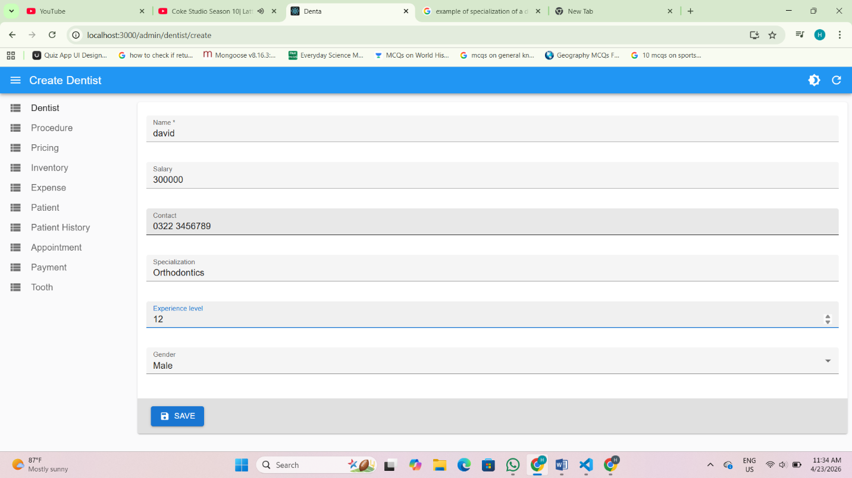

2. Procedure → Add all treatments (Root Canal, Cleaning, Filling etc.)

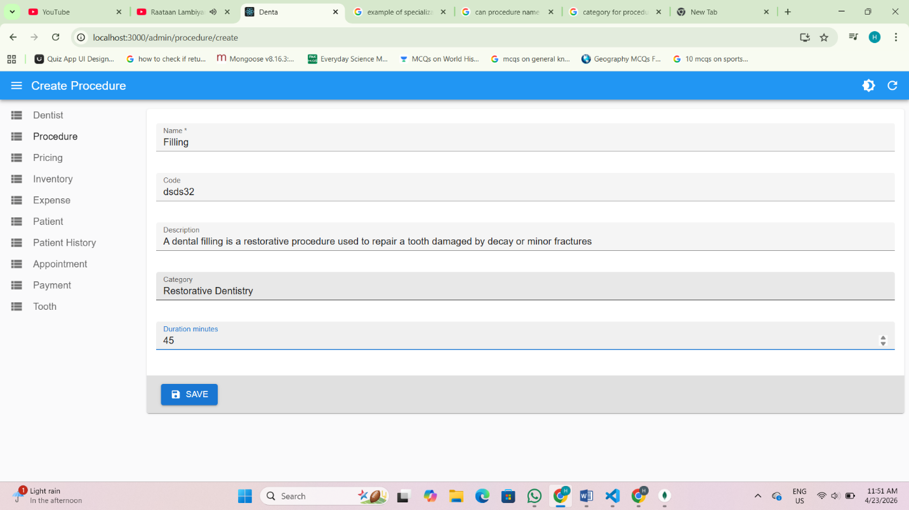

3. Pricing → Assign fees to each procedure (needs Procedure to exist first)

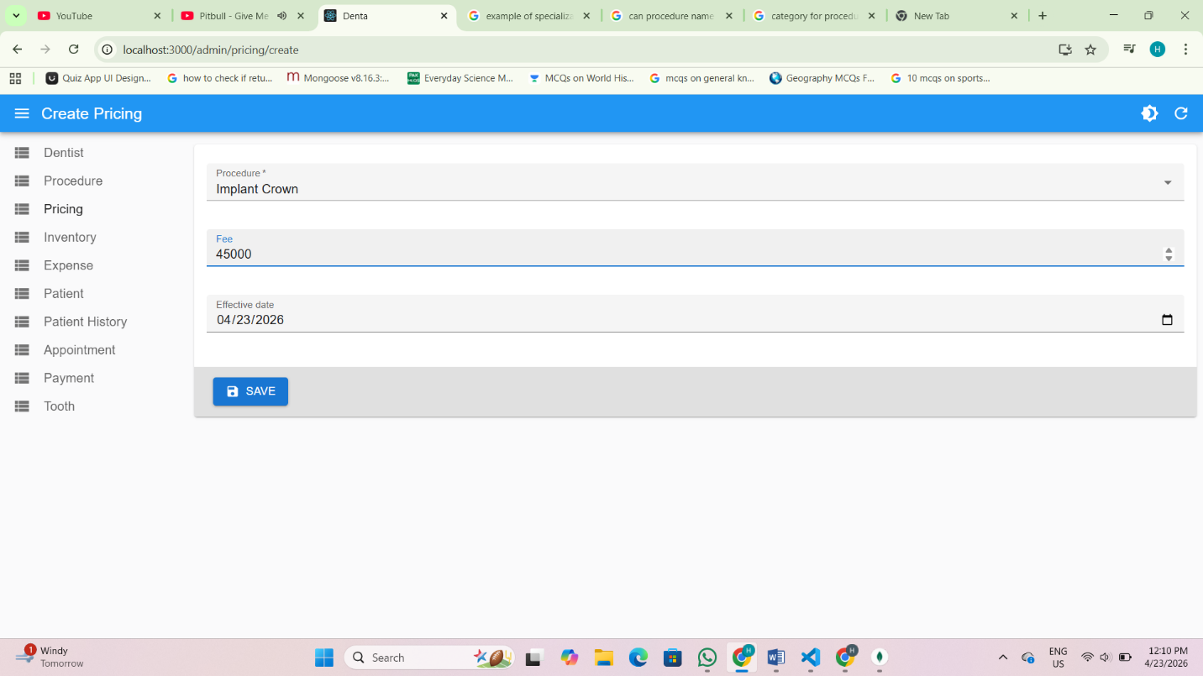

4. Inventory → Add all supplies/materials with quantity and cost

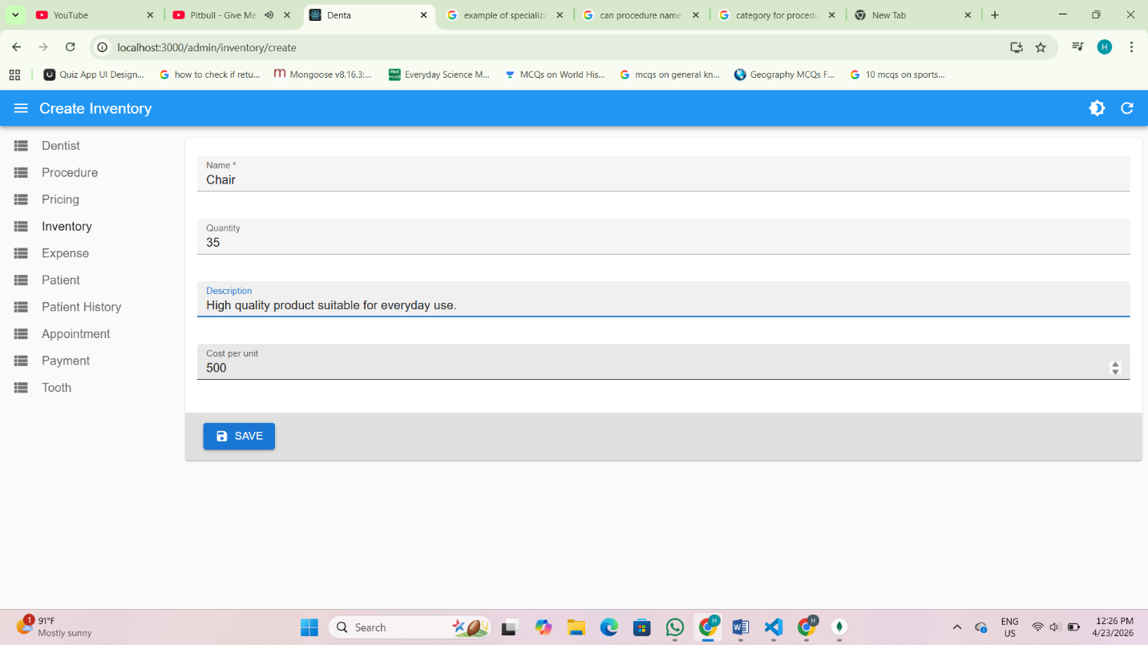

Phase 2 — Patient Registration (When a new patient arrives)
5. Patient → Register patient details (name, DOB, contact, gender)

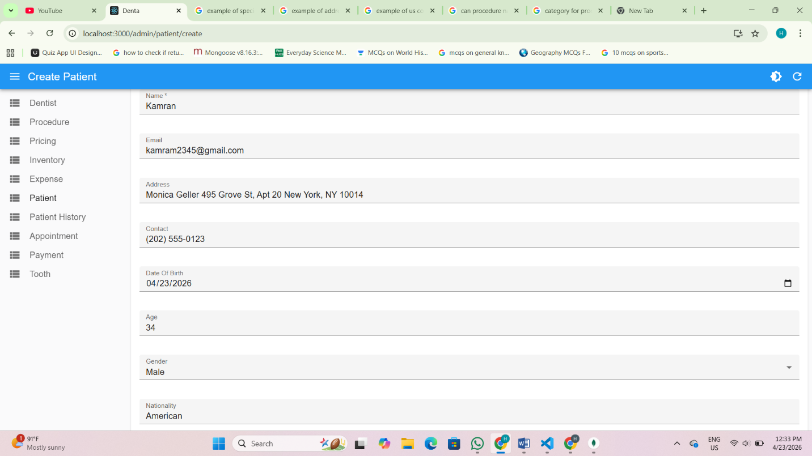

6. PatientHistory → Add medical background (chronic conditions, cavities, x-rays)

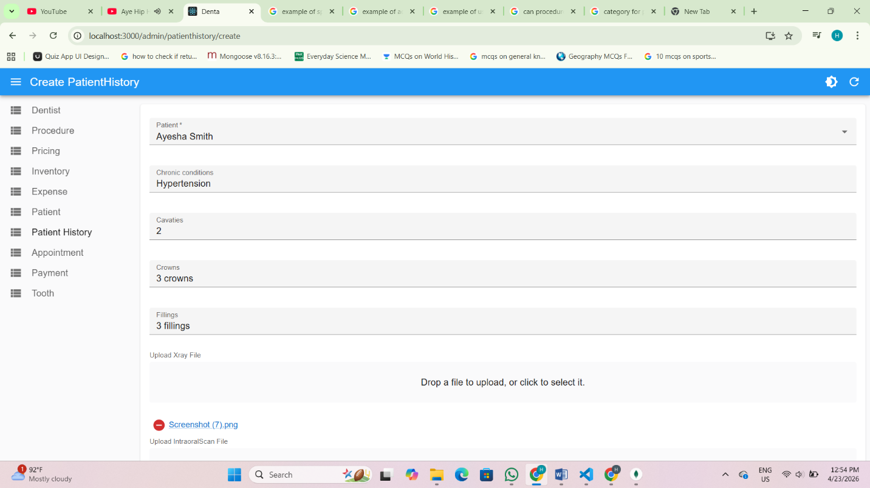

Phase 3 — Visit Flow (Every appointment)
7. Appointment → Book slot (needs Patient + Dentist already created)

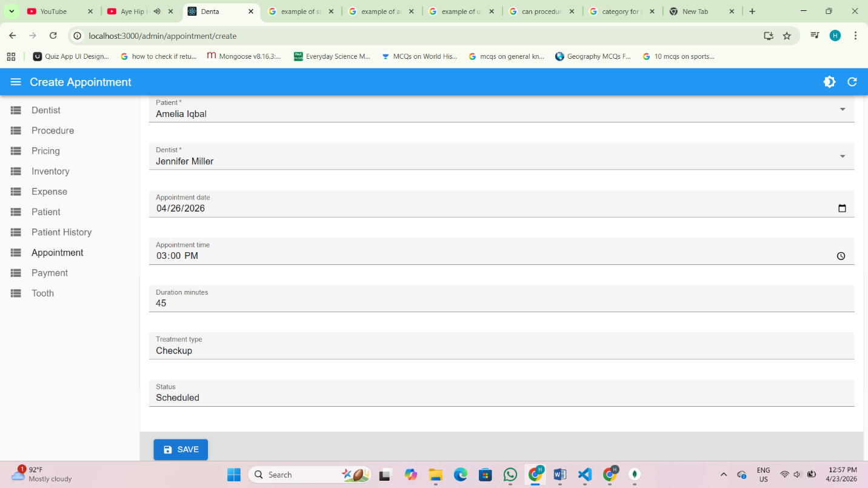

8. Tooth → Record which teeth are affected and planned procedures

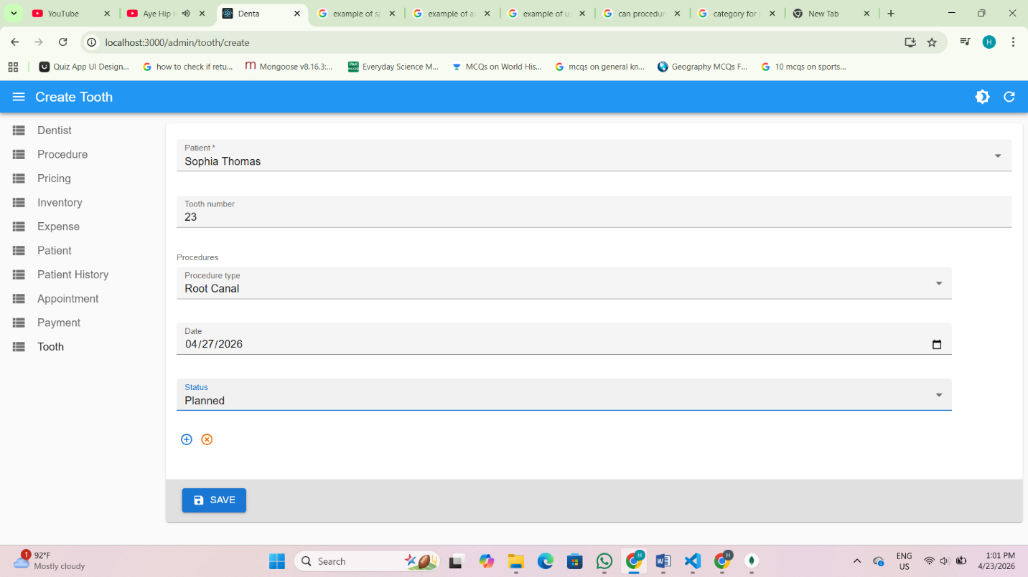

Also can add and view tooth related records in Patient record view where teeth map is used,click Save Procedures button to save tooth data

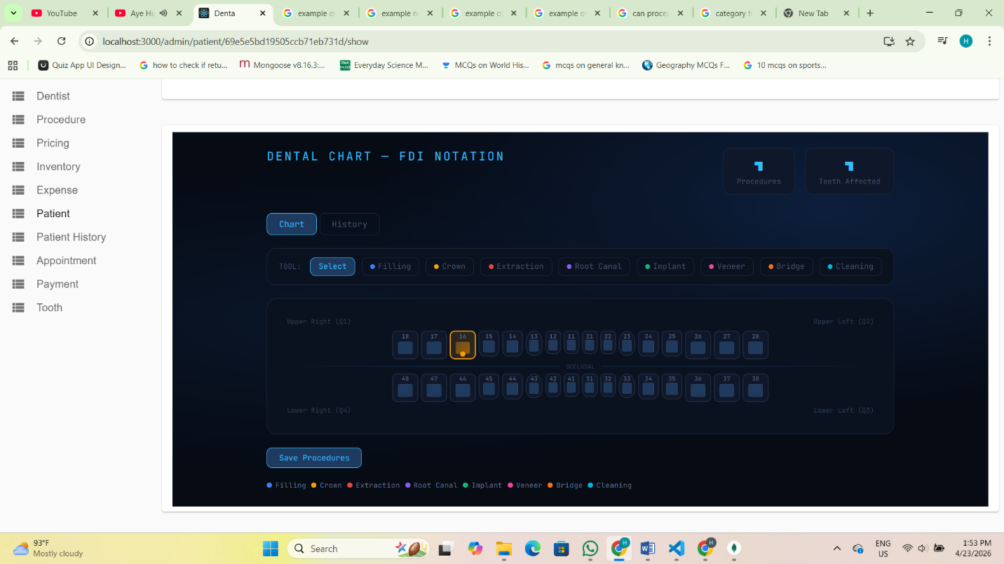

Phase 4 — Post Treatment (After treatment is done)
9. Expense → Log any materials/lab fees consumed during treatment

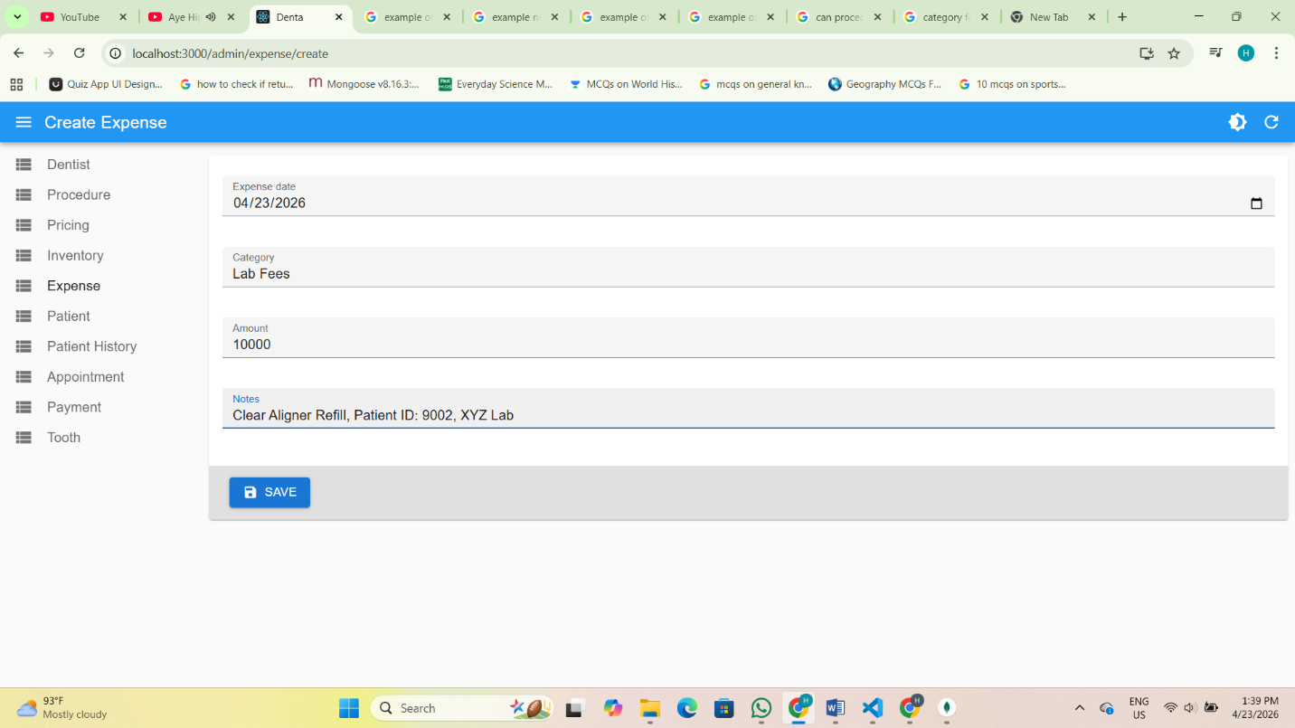

10. Payment → Record what the patient paid for the appointment
